1. A relational database contains two tables Student and Performance as shown below:

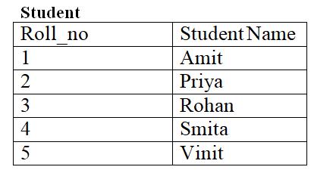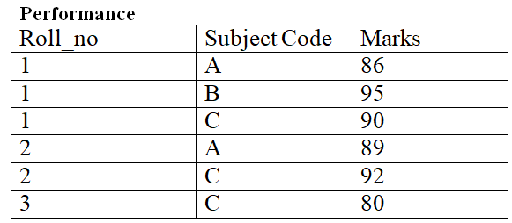

The primary key of the Student table is Roll_no. For the Performance table, the columns Roll_no. and Subject_code together from the primary key. Consider the SQL query given below:

SELECT S.Student_name, sum(P.Marks)

FROM Student S, Performance P

WHERE P.Marks > 84

GROUP BY S.Student_name;

The number of rows returned by the above SQL query is _________ .

1. Consider the following two tables and four queries in SQL.

Book (isbn, bname), Stock (isbn, copies)

Query 1:

SELECT B.isbn, S.copies

FROM Book B INNER JOIN Stock S

ON B.isbn = S.isbn;

Query 2:

SELECT B.isbn, S.copies

FROM B B LEFT OUTER JOIN Stock S

ON B.isbn = S.isbn;

Query 3:

SELECT B.isbn, S.copies

FROM Book B RIGHT OUTER JOIN Stock S

ON B.isbn = S.isbn;

Query 4:

SELECT B.isbn, S.copies

FROM B B FULL OUTER JOIN Stock S

ON B.isbn = S.isbn;

Which one of the queries above is certain to have an output that is a superset of the outputs of the other three queries?

(A) Query 1

(B) Query 2

(C) Query 3

(D) Query 4

1. Consider a database that has the relation schema EMP (EmpId, EmpName, and DeptName). An instance of the schema EMP and a SQL query on it are given below.

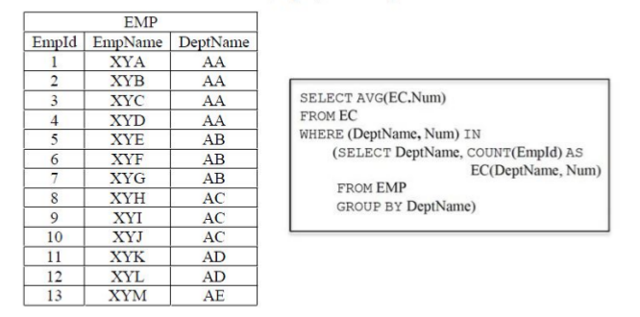

The output of executing the SQL query is _______.

1. Consider the following database table named top_scorer.

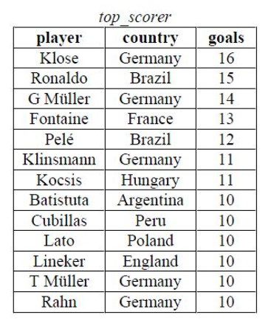

Consider the following SQL query:

SELECT ta.player FROM top_scorer AS ta

WHERE ta.goals > ALL ( SELECT tb.goals

FROM top_scorer AS tb

WHERE tb.country = 'Spain' )

AND ta.goals > ANY (SELECT tc.goals

FROM top_scorer AS tc

WHERE tc.country = 'Germany')

The number of tuples returned by the above SQL query is ____.

1. Consider the following database table named water_schemes :

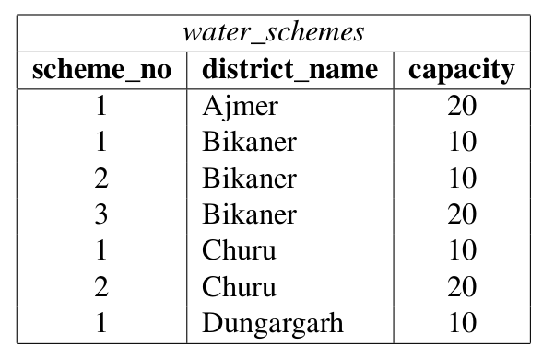

The number of tuples returned by the following SQL query is

with total(name, capacity) as

select district_name, sum(capacity)

from water_schemes

group by district_name

with total_avg(capacity) as

select avg(capacity)

from total

select name

from total, total_avg

where total.capacity >= total_avg.capacity

(A) 1

(B) 2

(C) 3

(D) 4

1. Select operation in SQL is equivalent to

(A) the selection operation in relational algebra

(B) the selection operation in relational algebra, except that select in SQL retains duplicates

(C) the projection operation in relational algebra

(D) the projection operation in relational algebra, except that select in SQL retains duplicates

1. Consider the following relations:

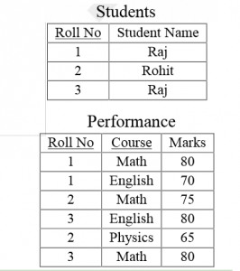

SELECT S. Student_Name, sum(P.Marks)

FROM Student S, Performance P

WHERE S.Roll_No = P.Roll_No

GROUP BY S.Student_Name

The number of rows that will be returned by the SQL query is _________

(A) 0

(B) 1

(C) 2

(D) 3

1. Consider the following relation

Cinema (theater, address, capacity)

Which of the following options will be needed at the end of the SQL query

SELECT P1. address

FROM Cinema P1

Such that it always finds the addresses of theaters with maximum capacity?

(A) WHERE P1. Capacity> = All (select P2. Capacity from Cinema P2)

(B) WHERE P1. Capacity> = Any (select P2. Capacity from Cinema P2)

(C) WHERE P1. Capacity > All (select max(P2. Capacity) from Cinema P2)

(D) WHERE P1. Capacity > Any (select max (P2. Capacity) from Cinema P2)

1. Given the following statements:

S1: A foreign key declaration can always be replaced by an equivalent check assertion in SQL.

S2: Given the table R(a,b,c) where a and b together form the primary key, the following is a valid table definition.

CREATE TABLE S (

a INTEGER,

d INTEGER,

e INTEGER,

PRIMARY KEY (d),

FOREIGN KEY (a) references R)

Which one of the following statements is CORRECT?

(A) S1 is TRUE and S2 is FALSE.

(B) Both S1 and S2 are TRUE.

(C) S1 is FALSE and S2 is TRUE.

(D) Both S1 and S2 are FALSE.

1. Given the following schema:

employees(emp-id, first-name, last-name, hire-date, dept-id, salary)

departments(dept-id, dept-name, manager-id, location-id)

You want to display the last names and hire dates of all latest hires in their respective departments in the location ID 1700. You issue the following query:

SQL> SELECT last-name, hire-date

FROM employees

WHERE (dept-id, hire-date) IN

(SELECT dept-id, MAX(hire-date)

FROM employees JOIN departments USING(dept-id)

WHERE location-id = 1700

GROUP BY dept-id);

What is the outcome?

(A) It executes but does not give the correct result.

(B) It executes and gives the correct result.

(C) It generates an error because of pairwise comparison.

(D) It generates an error because the GROUP BY clause cannot be used with table joins in a subquery

1. SQL allows tuples in relations, and correspondingly defines the multiplicity of tuples in the result of joins. Which one of the following queries always gives the same answer as the nested query shown below:

select * from R where a in (select S.a from S)

(A) select R.* from R, S where R.a=S.a

(B) select distinct R.* from R,S where R.a=S.a

(C) select R.* from R,(select distinct a from S) as S1 where R.a=S1.a

(D) select R.* from R,S where R.a=S.a and is unique R

1. Consider the following relational schema:

employee(empId, empName, empDept)

customer(custId, custName, salesRepId, rating)

salesRepId is a foreign key referring to empId of the employee relation. Assume that each employee makes a sale to at least one customer. What does the following query return?

SELECT empName

FROM employee E

WHERE NOT EXISTS (SELECT custId

FROM customer C

WHERE C.salesRepId = E.empId

AND C.rating <> `GOOD`);

(A) Names of all employees with at least one of their customers having a ‘GOOD’ rating.

(B) Names of all the employees with at most one of their customers having a ‘GOOD’ rating.

(C) Names of all the employees with none of their customers having a ‘GOOD’ rating.

(D) Names of all the employees with all their customers having a ‘GOOD’ rating.

1. Consider the following tables A, B and C.

Table A

Id Name Age

----------------

12 Arun 60

15 Shreya 24

99 Rohit 11

Table B

Id Name Age

----------------

15 Shreya 24

25 Hari 40

98 Rohit 20

99 Rohit 11

Table C

Id Phone Area

-----------------

10 2200 02

99 2100 01

How many tuples does the result of the following SQL query contains?

SELECT A.id

FROM A

WHERE A.age > ALL (SELECT B.age

FROM B

WHERE B. name = "arun")

(A) 4

(B) 3

(C) 0

(D) 1

1. Database table by name Loan_Records is given below.

Borrower Bank_Manager Loan_Amount

Ramesh Sunderajan 10000.00

Suresh Ramgopal 5000.00

Mahesh Sunderajan 7000.00

What is the output of the following SQL query?

SELECT Count(*)

FROM ( (SELECT Borrower, Bank_Manager

FROM Loan_Records) AS S

NATURAL JOIN (SELECT Bank_Manager,

Loan_Amount

FROM Loan_Records) AS T );

(A) 3

(B) 9

(C) 5

(D) 6